NAME: **YVONNE KIMANI** REG NUMBER: **SCT212-0475/2017**

## ASSIGNMENT

1. **Provide a summary of the language recognized by the machine**

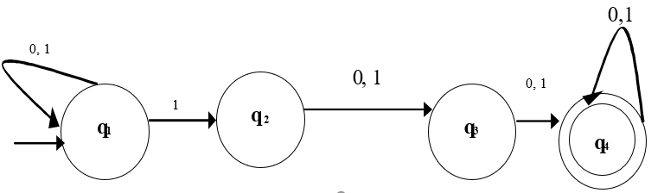

Some of the possible paths that the machine can take include

0

0

1

1

0

q1 q1 q1  q2 q3  q4 String: **01100**

1

1

1

q1  q2 q3  q4 String: **111**

1

1

0

q1  q2 q3  q4 String: **110**

0

1

1

1

q1 q1  q2 q3  q4 String: **0111**

0

1

0

1

0

q1 q1 q1  q2 q3  q4 String: **10100**

0

0

1

q1  q2 q3  q4 String: **100**

The machine recognizes the language as long as it consists of strings with at least one 1.

1. **Describe how the machine transitions on input 00011.**

(q2, $) ∈ δ (q1, ∈, ∈)

(q2, 0) ∈ δ (q2, 0, ∈)

(q2, 0) ∈ δ (q2, 0, ∈)

(q2, 0) ∈ δ (q2, 0, ∈)

(q3, ∈) ∈ δ (q2, 1, 0)

(q3, ∈) ∈ δ (q3, 1, 0)

(q3, ∈) ∈ δ (q3, 1, 0)

(q4, ∈) ∈ δ (q3, ∈, $)

Input string 000111 is accepted since q4 is an accept state

1. **Identify the error in the transition table provided for the same machine in the formal description.**

(q2, 0) ∈ δ (q2, 0, ∈)

(q3, ∈) ∈ δ (q2, 1, 0) => Correction For the error

(q3, ∈) ∈ δ (q3, 1, 0)

(q4, ∈) ∈ δ (q3, ∈, $)

(q2, $) ∈ δ (q1, ∈, ∈)

(q3, ∈) is the correct transition from (q2, 1, 0) not (q2, ∈)